📝 Notes
May 6, 2026

Contained Animal Management System | Solution Lab 4
Invited Christian Ruiz Francisco Perez Tyler Morton Raul Montenegro Claudiu Constantin wyldsolconsulting@gmail.com
Attachments Contained Animal Management System | Solution Lab 4
Meeting records Transcript Recording

Summary
Team established Minimum Viable Product priorities through a systematic backlog review and critical feature classification.
Defining MVP Scope
Backlog review initiated through MoSCoW prioritization. Onboarding and subscription features confirmed as Must-Haves.
Core Feature Prioritization
Dashboard metrics, inventory management, and media handling deemed essential. Must-Haves include bulk import and private media access.
Integration and Settings
Event data and payment integrations classified as Must-Haves. Content generation features officially excluded from current scope.

Rate this Summary: Helpful or Not Helpful

Decisions
We've updated the Decisions section using your feedback.
Let us know what you think: Helpful or Not Helpful

ALIGNED
- Animal Profile Features Added The product requirements are expanded to include comments on animal profiles, the ability to select a favorite animal picture, and a feature to remove uploads.
- MVP Scope Prioritization The MVP scope is defined via MoSCoW prioritization to include Onboarding, Subscriptions, Dashboard metrics and setup, Inventory management, Media management (excluding download media), Events data integration, Notifications, and Settings, with other features like lineage data, financials, and marketing tools categorized as non-MVP.
- User Flow and Settings Update The user onboarding flow is set to sign-up, account confirmation, subscription selection, and account setup, and the settings module will include location management.

Next steps
- [Francisco Perez] Send Recap: Send meeting notes and finalized backlog later today for team review.

Details
Did the screenshots in this section make your notes better or worse?
- MVP Definition and Backlog Review: The meeting focused on defining the Minimum Viable Product (MVP) through a prioritization exercise, which served as a confirmation of existing priorities and aimed to fill gaps in the initial backlog (00:00:00). The team reviewed the existing backlog, divided into epics and stories, to prepare for the MoSCoW prioritization exercise, which groups items into Must-Haves, Should-Haves, Could-Haves, and Will-Not-Haves for the first version (00:01:09). The next meeting will be the final design review scheduled for tomorrow (00:00:00).
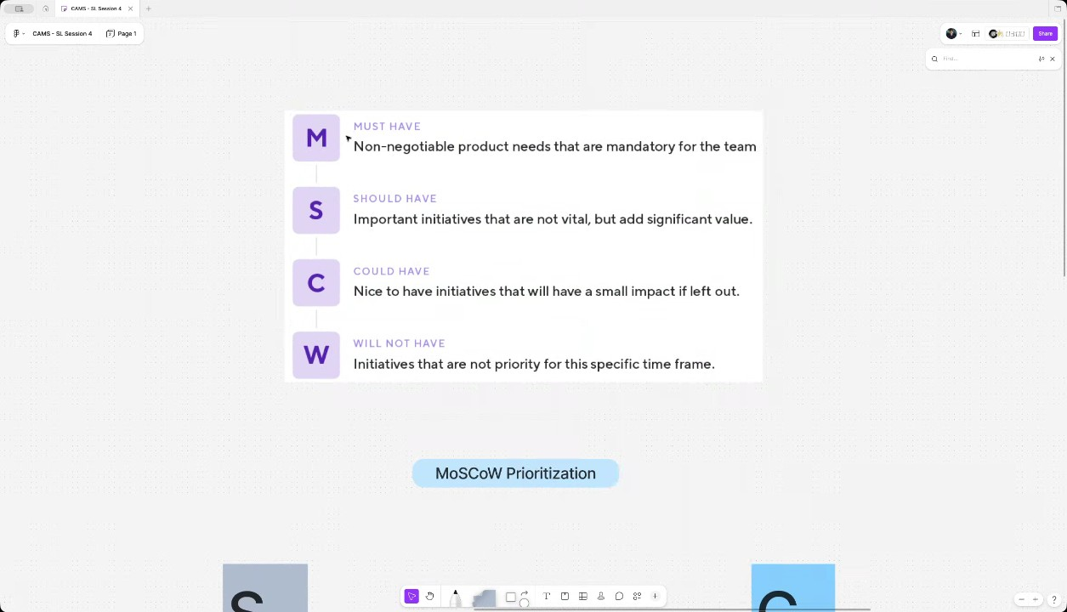
- Onboarding and Subscription Features: The onboarding epic includes email and password authentication, social login (Google and Apple, with Facebook as a possibility), profile setup, and bulk import. The subscription features, which were separated due to their nature, involve showing plans/tiers based on quotas and handling the payment flow for the subscription (00:02:06). The group agreed that all onboarding and subscription features should be classified as Must-Haves for the MVP, as they do not plan for a friends and family release that would bypass the need for paying customers from the start (00:11:15).
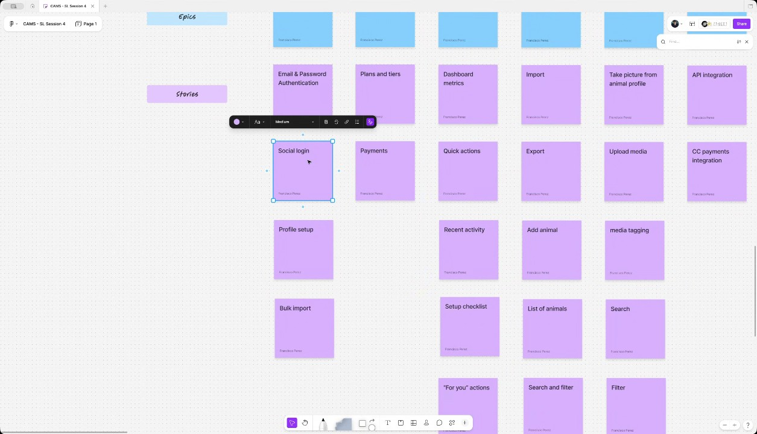
- Dashboard and Inventory Management Features: The dashboard section, which serves as the home screen, was defined as a Must-Have, specifically needing the metrics section and the setup checklist (00:12:16). Quick actions and recent activity were prioritized as items that could be added later (00:13:07). For inventory management, which is a core feature, all proposed features were deemed Must-Haves, including bulk import/export (with the template feature added as a note), adding/listing animals, and editing animal details, with the export function serving as a useful report feature (00:04:07) (00:07:57).
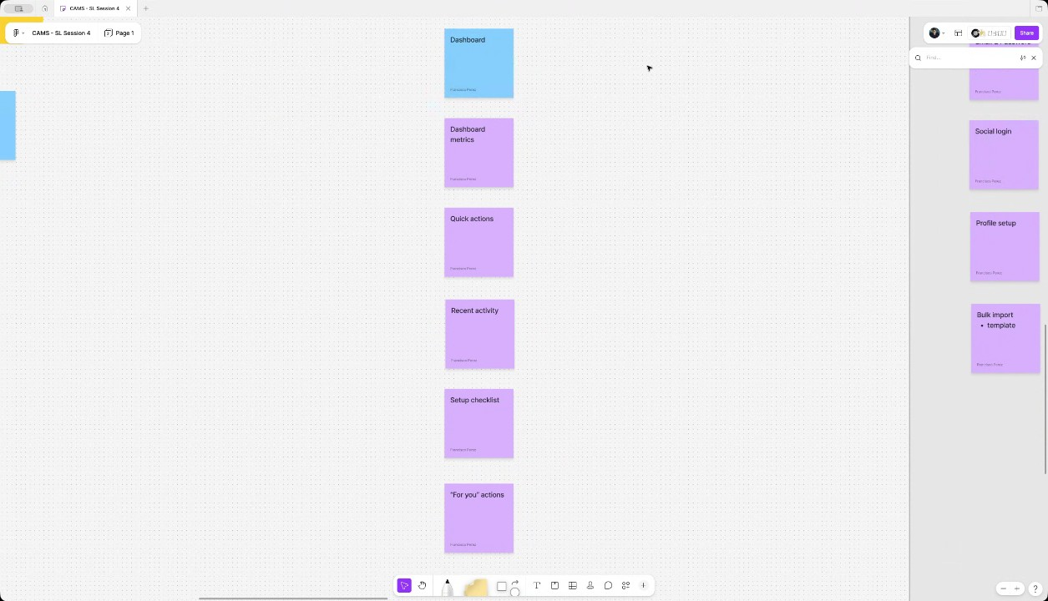
- Media Management Features: Critical media features were classified as Must-Haves, including the point-and-shoot functionality, media upload, and the associated tagging, searching, and filtering capabilities (00:14:12). Additionally, the ability to manage private and public media access is a Must-Have because users will be uploading practice materials that they do not want partners to view. Other essential Must-Haves include the ability to add links, include comments (including on the animal profile), remove uploads, and implement the upload queue/retries feature to maintain user trust in system reliability; however, the download media feature could be taken out of the Must-Have list (00:08:51) (00:15:04).
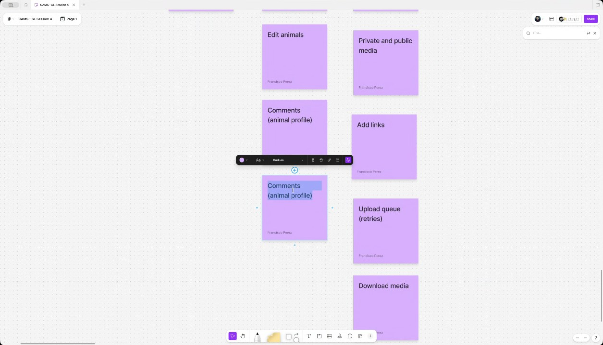
- Integrations, Notifications, and Settings: Integration for event data, which involves data extraction because there is no API, was classified as a Must-Have for the MVP, while the API integration for lineage data was designated as a Could-Have due to ongoing compensation discussions (00:18:52). Credit card payments integration is also a Must-Have due to the priority of subscriptions. All proposed notification channels (push, text, email) and the invite system for partners were agreed upon as Must-Haves (00:19:54). Settings related to statuses, tags, branch/location information, and partner/user management are required for the MVP, with "brochures and content generation" and "financials and automated billing" being confirmed as Will-Not-Haves for the current scope (00:20:52).
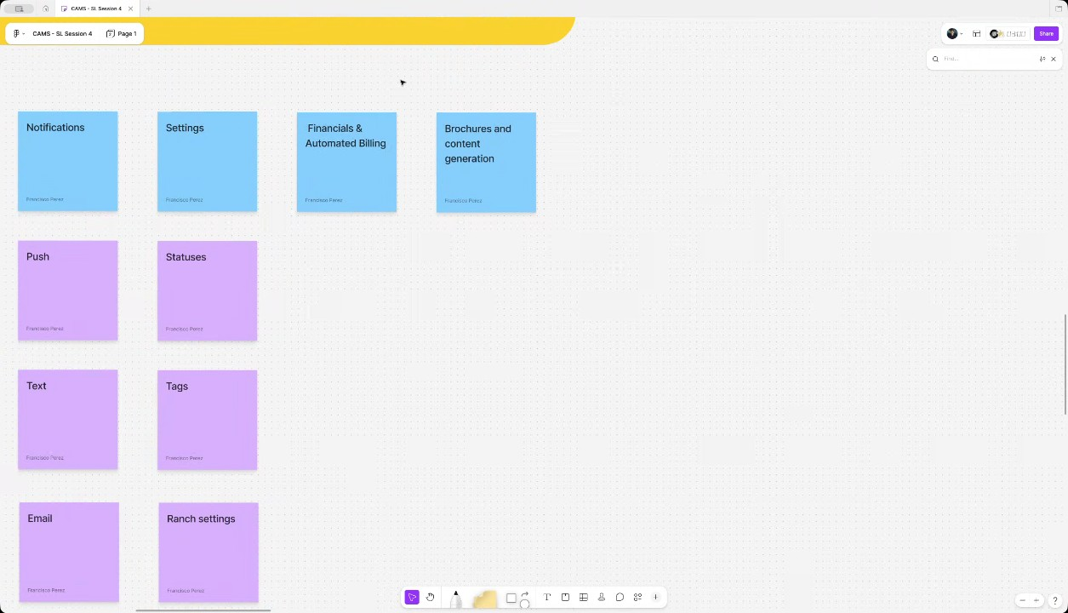

You should review Gemini's notes to make sure they're accurate. Get tips and learn how Gemini takes notes
How is the quality of these specific notes? Take a short survey to let us know your feedback, including how helpful the notes were for your needs.

📖 Transcript
May 6, 2026

Contained Animal Management System | Solution Lab 4 - Transcript

00:00:00

Francisco Perez: shop. As I mentioned, we're going to be focusing on defining the MVP through a prioritization exercise. Although for this specific project, I know we already have the priorities pretty well set uh in mind. That's going to be more of a confirmation double checking of what we have been discussing so far. And um also filling in maybe some gaps in the in the initial backlog that we created. So, I'm going to explain that in a second. But before that uh just to note tomorrow we have another meeting this time the last design review. So we're going to see the latest updates to the design file um tomorrow. Okay. So let's get started with this session. Uh as I mentioned today we want to first review what's the initial backlog that we find. This backlog was created more like uh let's say a um a conclusion of the discussions we have been having so far at the level of the solution lab. But the idea is that this is later taken on by the team to be better defined at you know uh let's say a higher fidelity level of uh task or activity that needs to be done for implementation.

00:01:09

Francisco Perez: Uh so it's not meant to be the most exhaustive in terms of technical tasks or in terms of the division but the idea is that it covers the general sense of the of the product itself and in order to define the MVP after reviewing this backlog we're going to do the mascow prioritization uh because we have focused a lot on the on the MVP in the discussions I think most of the things are going to be actually in the in the in the MVP but the idea is that we go through all of the epics and stories here in the in the backlog and we group them into one of these four categories must haves, uh should haves, could haves or will not haves for the scope of the MVP. Right? So for the scope of the first version, uh that's the context on to which these uh descriptors work. So I don't know if you have any questions uh before we we start. Okay. Nice. So let's begin with the uh the backlog. So we have divided them into epics and stories.

00:02:06

Francisco Perez: Uh let's begin with the first epic uh is the on boarding itself right so basing it off from the designs and discussions we had uh for the onboarding we need to have an email and password authentication we have social login for both uh Google and and and Apple and we also discussed uh maybe the possibility of Facebook at some point uh we have the profile setup and the bulk import of the anim on boarding u Then as part of the onboarding process but I separated it because of the of the nature of of the feature we have the subscriptions.
WyldSol: Let's
Francisco Perez: Uh so for the subscriptions at this moment what we have envisioned is first showing of the plans and tiers once again based on the quota or the or the number of animals that we we have considered and the payment itself for the subscription. So the flow for the subscriptions these plans and tears activities should for example later be broken down into the actual um the actual feature set of each. So in this case the quota uh rules but uh this also includes the display of those uh tiers right of clients right when when you are uh purchasing the the subscription.

00:03:15

Francisco Perez: Uh so that makes up the first step in the platform which is the on boarding. Then we have the dashboard for the dashboard we have uh first as the section of the metrics themselves. Uh we have in the UI we have some quick actions uh that you can do. In the case of the MVP for example, it's going to be limited to media management. But the idea is that as as we build more features, it's going to include all the activities. Uh we have the recent activity which is just kind of like a log event log of the things that happen in the system in your account. Uh we have a setup checklist. So basically if we're missing anything, for example, inviting partners, uh doing the bull capital because it's skippable or anything like that, it's going to be over there to be to be continued. And we have some for you actions which are just simply just some quick actions. Once again, this just as with the quick actions, but in this case for recommended for you.

00:04:07

Francisco Perez: Uh it's going to be expanded once we have more more features built into the system. And that's the main home screen dashboard. Then we get to the inventory management. At this point, we can both import and export the the animals. Uh the import process is the same bulk upload. The export should be simply a spreadsheet export, right? As I recall, uh we can individually add one animal, have the list of animals in the in the actual table view, which can be searched and filtered, and we can edit animals. I didn't include the the delete because I guess if we were just going to disable it or change the status to to something, it's built more into the edit uh activities.
WyldSol: Mhm.
Francisco Perez: For each one of the items in the inventory, we can manage the media. So, we have uh first take picture from the animal profile. So basically this is the point and shoot let's call it like that point and shoot functionality for the picture taking. We can upload media if that's already in a gallery or or in the computer and we do we can do the process of media tagging searching and filtering by both tags but also dates and many other um uh many other criteria.

00:05:19

Francisco Perez: Uh we have the private and public media toggles or or accesses. So basically this this should contain the rules or enabling or disabling the public view of the of the actual media that you upload or the the stakeholders. Uh we can add links apart from pictures and we have other complimentary features here. So for example the upload Q basically this is the retries right. So the scenario where you have no no data or maybe you take a picture and and it's going to be uploaded uh or continue the upload if it's interrupted. uh we have the download media feature this is for the stakeholders and the comments add comments right so in this case the comments with the threaded feature functionality that we have discussed so far um I included one task I'm going to color code it differently because these are this is just technical but I included it just for us to not forget uh we have first the API integration this is for the lineage data right the ones that that we discussed so I'm going to actually add that comment uh linkage data and the other integration we have is the credit card payments at this point uh which is for the subscription itself right so in this case it should be kind of like just a setup for whatever we're we're going to be using and normally it's a stripe but if we have other we want to explore other options that's also fine

00:06:39

Francisco Perez: uh those should make up the integrations up to this point um then we have notifications so for notifications we have push text and email which are the three main channels This should include or or infer uh implicitly includes the the main notifications, right? So when a new picture is enabled, comments, anything that that is global. And the other notification that is a little bit different because it's for someone that is not in the platform yet are the invites. So these are the invites for partners for any other potential stakeholder. Uh they should receive an invite email. So or text. So that's the what is included also here in the notifications uh settings which in this case it's mostly the configuration of statuses tags the branch information itself and the partners and users management. Uh so here is where you would be able to invite more people to the account for example and change the different parameters of ownership of uh you know what you want them to see and and not u then I didn't include the detail for these two because I guess these are more both MVP related but brochures and content generation this is all of the marketing creation based on the media and the financials and automated billing which are the the features for generating invoices paying invoices getting paid by the invoices and all of the things we have discussed.

00:07:57

Francisco Perez: cost uh that are after the first MVP release. So, I just want to stop here because I know that was a mouthful. I don't know if you have any any questions, any comments, anything that you think may be missing here.
WyldSol: um with the import and or the bulk import both of those um we had the thought of a template there. Is that
Francisco Perez: Oh, right.
WyldSol: just
Francisco Perez: uh for the template uh what I was thinking is yeah for it to be included in the in the actual bulk import feature. I'm going to add it as a comment though because I think it's important uh but I I guess the template is mostly providing them
WyldSol: okay?
Francisco Perez: a file they can fill in right with the format.
WyldSol: Yeah. Yeah. Like a format that we want them to fill in.
Francisco Perez: Okay.
WyldSol: Um and then uh we only have comments on the
Francisco Perez: Yep.
WyldSol: media and we wanted to have comments on the animal as well.
Francisco Perez: On the profiles, right? Yeah, that's true.

00:08:51

Francisco Perez: I forgot that. Yeah.
WyldSol: Yeah.
Francisco Perez: Yeah. Comments on on the animal profile, but it's true.
WyldSol: And then under the integrations, you have the lineage data, but there's also it's the same place, but it's different data around the events.
Francisco Perez: Okay.
WyldSol: Um, and that's all the notes I took.
Francisco Perez: Okay. Yeah.
WyldSol: So,
Francisco Perez: And as I mentioned, I know we have many other plans after the MVP, but um I just wanted to include these ones because I know these ones are maybe the sensible next steps after we have the media implemented. Uh so so yep. Yes, Claudia. Go
WyldSol: Yeah.
Claudiu Constantin: Uh there's one more feature when adding an animal to the inventory is selecting a favorite picture
Francisco Perez: ahead.
Claudiu Constantin: of some sort so that we can highlight it and use it in the cover of the animal itself and on
WyldSol: Thank you.
Claudiu Constantin: the tables.
Francisco Perez: That's important.
Claudiu Constantin: Just for a quick reference on who's
Francisco Perez: Yeah.
Claudiu Constantin: who. I think that's it.

00:10:04

Francisco Perez: Okay. All right. Um Okay. So, if that's uh good enough as as an initial backlog, then let's do the prioritization. Once again, let let's uh go through the different categories here. Uh the idea of this is for us to define what's going to be implemented first, second, third, and later, right? So, uh, let's take this as, uh, not necessarily what's going to be included or not in the MVP because most of the tasks we have are actually I could actually drag most of these into into the MOS, right? Because that's that's going to be our MVP, but rather the the the order of execution if you wish,
WyldSol: Yeah.
Francisco Perez: right? Um so that if there is a chance that uh the project um you know it's it's could be released earlier if with a specific feature set we can have testers or or any friends and family before. So let's begin with the categorization the grouping um and let's start with the on boarding. So for the on boarding process um because we have both the mobile and the considering these features by the way are considered both the mobile and the web implementation.

00:11:15

Francisco Perez: So let's begin first with uh these I think that we need all of them or the or both maybe the social login could be the prioritize but I guess you know it's not that big of a of a lift. So I would add all of these as a must. I don't know if you agree with me on this one.
WyldSol: I do
Francisco Perez: Okay,
WyldSol: agree.
Francisco Perez: let's have them all here as musthaves and uh this this is other epic is a little bit more interesting. Do you think the subscriptions should be something that is fried at the beginning? Maybe that's something that maybe I'm I'm asking more about the plan itself, right? So I don't know if you have planned to have maybe a friends and family release. Uh in that case maybe the description is not as relevant as a first priority maybe as a second iteration.
WyldSol: Um I mean there no we don't we don't plan to have a fam family and friends.
Francisco Perez: Okay.
WyldSol: I mean there's two stakeholders that are going to be the free people.

00:12:16

Francisco Perez: Okay.
WyldSol: I think every I think this would be a must have.
Francisco Perez: Right. Sure. Yeah. Maybe that that was the question, right? If if the first user we expect them to be well the first let's say five users we expect them to be paying customers or just uh trying it. I guess yeah it's the most u now we can also
WyldSol: Yes.
Francisco Perez: divide here some of them um so for example in the dashboard uh this makes up the home screen and I think that a lot of these things are actually you know once again maybe not that big of a of a of a lift but I just wanted to ask if well that we do need a place for for users to to land on right after they they on board. So the dashboard definitely in my eyes at least is a must have. Uh but I don't know if all of these do you think all of these are required in the dashboard. I guess the metrics are really important.

00:13:07

Francisco Perez: That's what we define as the as the
WyldSol: I would say the must have would be the dashboard,
Francisco Perez: main
WyldSol: the metrics and the
Francisco Perez: right.
WyldSol: setup.
Francisco Perez: So maybe this recent activity quick actions could be added later. Right. Okay. Let's do that. All
WyldSol: Yeah.
Francisco Perez: right. Now, as for the inventory management, um here this is kind of like the the main one of let's say the first half of the main feature of the MVP. I don't think there's anything here that could be left out. maybe the the the export, but but I guess this could also be super useful and it's not that big of a of a of a of a lift again, right? So, I don't know if you think this is all must
WyldSol: Yeah,
Francisco Perez: haves,
WyldSol: I'd put it in all must haves because they'll use that export to double check once they get in. They'll pull it out.
Francisco Perez: right?
WyldSol: That's kind of people they are just to kind
Francisco Perez: Yeah.

00:14:12

Francisco Perez: And it could also work as a as a sort of report,
WyldSol: of Yeah.
Francisco Perez: right? I guess because once you already have it like like sometimes you really wish you had some data in a system
WyldSol: Yeah.
Francisco Perez: but you also had a spreadsheet of it to run maybe create some custom graphs and could be relevant at the
WyldSol: Yeah.
Francisco Perez: beginning even if we don't have any specific reports like that. Um okay now the next feature the media. So for the media um uh okay so the point and shoot feature I think this is the main um the main selling point of this right not having to to tag it later. Sorry.
WyldSol: It is,
Francisco Perez: Um,
WyldSol: but the upload media is if they're going to trust it, they need to be able to upload everything they have now into it.
Francisco Perez: right.
WyldSol: So,
Francisco Perez: Yeah.
WyldSol: that one's equally as important as
Francisco Perez: Right.
WyldSol: important.
Francisco Perez: And with that comes obviously the tagging, searching and filtering. It's also part of it.

00:15:04

Francisco Perez: The private and public media. Um, do you think this is needed at the at the right at the beginning? Uh, like what is the expected use of this? Do you think they are going to be uploading private pictures uh from the start?
WyldSol: Yes. Because they do practice and so they won't want they won't want their partners to see the
Francisco Perez: Okay.
WyldSol: practice.
Francisco Perez: Okay. Yeah, the links I think the links is is fairly simple. I I would wouldn't take it out just because of how how easy it is, how quickly it is to to implement it. Um download media and comments uh and upload Q. I guess the comments is the the main interaction for the stakeholders for for the partners. So I wouldn't leave it out just because that's the let's say the only interaction they have uh with the the animals themselves. Uh how about the the use case of the upload q/ retries? Do you think this is a must or
WyldSol: I think it's a must because the first time something doesn't load then they don't trust the system.

00:15:57

Francisco Perez: Okay.
WyldSol: I would say you could take download media out um but all the rest would be a
Francisco Perez: Okay.
WyldSol: must.
Francisco Perez: All right. Yeah. Let's leave it like that
Claudiu Constantin: We might have one more thing here about media management.
Francisco Perez: then.
Claudiu Constantin: Um, so basically actually removing some uploads that you
Francisco Perez: Oh, that's true. Yeah, you're right.
Claudiu Constantin: had
Francisco Perez: That's definitely be a must
WyldSol: Yeah.
Claudiu Constantin: and maybe reorganization features as a bonus,
Francisco Perez: have.
Claudiu Constantin: dragging them around in a specific order. Maybe folder approach. Maybe you know you separate them by location.
Francisco Perez: You mean kind of like having a more structure to the to the to the albums?
WyldSol: Okay.
Francisco Perez: Yeah, I guess I guess so far we we discussed only adding media,
Claudiu Constantin: death.
Francisco Perez: right? Not necessarily organizing it in that way.
Claudiu Constantin: Yeah.
Francisco Perez: uh could be by tax or do you think it's what's your take on this? Um do you think it's it's based on the tax or or having another level of

00:16:58

Claudiu Constantin: Uh not really. Tags are there mostly just to help with search,
Francisco Perez: organization?
Claudiu Constantin: but uh I'm thinking of uh not folders necessarily, but maybe structuring them by sections maybe. So,
Francisco Perez: Okay.
Claudiu Constantin: um, grouping in general, I would say, because maybe you want to group them by year, by month, um, maybe you want to have a custom grouping, uh, I don't know, uh, she was growing here or I don't know, just specific management features because a lot of features are going to be added probably along the time and uh,
WyldSol: Mhm. Mhm.
Claudiu Constantin: you might want to end up um, with a clean way of showing them by a structure for everyone to
WyldSol: Yeah, that's Yeah,
Claudiu Constantin: see.
WyldSol: I think you're right.
Francisco Perez: I I like that.
WyldSol: I think that'd be huge.
Francisco Perez: Yeah, I think that's a pretty
Claudiu Constantin: Maybe not for MVP,
Francisco Perez: good
Claudiu Constantin: but just to keep in mind on how we can expand on these
Francisco Perez: Yeah, that's a good question.
WyldSol: I like that

00:17:57

Francisco Perez: Do you think this should be?
Claudiu Constantin: features.
Francisco Perez: Yeah,
WyldSol: part.
Francisco Perez: I was going to I was going to ask that exactly because I was thinking, you know, the the best case scenario, they really like the media management of that we provide with the tax. So, it maybe could be frustrating uh having just like kind of like a camera role, right? Instead of being able to do them.
WyldSol: Yeah,
Francisco Perez: And I guess what we
WyldSol: because they currently make they currently in their phones right now create folders to put
Francisco Perez: right they may already be used to to that way of managing media.
WyldSol: the stuff in.
Francisco Perez: So I guess what you know we could also expand it later right maybe we don't necessarily need to have all of the
WyldSol: Yep.
Francisco Perez: groupings at the beginning but but I think it is important to at least have some custom grouping that they can create okay uh all right
WyldSol: Yeah.
Francisco Perez: the integrations this is a pretty interesting one uh I don't know how the conversations have been going with uh with the the the provider for this API

00:18:52

WyldSol: Yeah. So, um, the lineage data we're working with them on now has turned into a compensation conversation. Um, so I would split that one in two. Um,
Francisco Perez: Is
WyldSol: the events data are they just put the year's worth of events out in January. Um, rarely do they ever add one. So, and they don't have an API on it.
Francisco Perez: Okay. Yeah. So,
WyldSol: Um,
Francisco Perez: this one is more kind of like a a scraping slash data extraction project.
WyldSol: yeah.
Francisco Perez: Okay.
WyldSol: And so if we could put that,
Christian Ruiz: Yeah.
WyldSol: if we could put the event scrape in MVP and leave the lineage in could, I would put it in should.
Francisco Perez: Okay.
WyldSol: I'd put it in could.
Francisco Perez: Right. So, so if I got it correctly, the API integration should be a should have, right?
WyldSol: I could have.
Francisco Perez: Uh could have. Okay.
WyldSol: Yeah.
Francisco Perez: and the the events is the the one that actually is for the MVP we're describing along with obviously the

00:19:54

WyldSol: Yeah.
Francisco Perez: oh sorry the credit card payment uh because we have the subscriptions um into this
WyldSol: Yeah.
Francisco Perez: okay now notification channels I know that we we landed on push and text being the main priorities obviously the invites are needed because that's how the stakeholders are going to enter the partners are going to enter the platform the email notifications is not that much of a of a lift anyways but I don't know if Do you think this is also a
WyldSol: I don't think it's a must have for the media or anything like that.
Francisco Perez: muscle?
WyldSol: Um, is is the email necessary for the invites? I mean, I wouldn't
Francisco Perez: I guess it could be depending on we could also do do them by text, but I guess email is normally where you receive
Christian Ruiz: It is
Francisco Perez: those.
Christian Ruiz: female.
WyldSol: Yeah. Okay.
Francisco Perez: Yeah.
WyldSol: So, yeah, I would put them all in
Francisco Perez: Okay,
WyldSol: there.
Francisco Perez: great. Yeah, I also agree with that. And anyways, it's just another channel, right?

00:20:52

Francisco Perez: Shouldn't be that big of a of a deal. Uh,
WyldSol: Yeah.
Francisco Perez: now in terms of the settings and the things that you can um set up in the in the platform, uh, statuses and tags are the main ones. I don't know if we're missing something here because uh Oh,
WyldSol: Uh,
Francisco Perez: yeah.
WyldSol: type.
Francisco Perez: Um, so this is basically the the the on boarding information also. So it's kind of like just an edit of what you already did. And the partners are users. Uh, I guess all of this is actually for the MVP, right? You got you got to set up everything.
WyldSol: Yeah.
Francisco Perez: Okay,
WyldSol: Yeah.
Francisco Perez: great.
WyldSol: And yeah, I think depending on the wizard that we have,
Francisco Perez: Yeah.
WyldSol: I think those kind of go in the onboarding or whatever we were thinking. So those are will not have for
Francisco Perez: Okay. All right.
WyldSol: MVP.
Francisco Perez: Um and last but not least, financials, automated billing, brochures, and content generation. Exactly.

00:21:55

Francisco Perez: Those two are not not a VP as you mentioned. So, uh, I guess we could put them as won't at the moment because those are not not really a a
WyldSol: Yeah.
Francisco Perez: priority or concern right now. Okay. All right.
Claudiu Constantin: as for the on boarding.
Francisco Perez: So,
Claudiu Constantin: One quick mention uh the newest the newer structure is they sign
Francisco Perez: yeah.
Claudiu Constantin: up confirm their their account they pick their subscription and then they start the on boarding process which is setting up their profile invites if applicable importing which is skippable of course. So basically now we have sign up then subscription otherwise they cannot really go in once they pay and everything is set up because they know their requirements more or less then they start setting up their account but at least we know that you know they signed up everything is done they're our client clients
WyldSol: Okay, I like that. Um, that brings up one thing that we should add to the settings. It is location as well.
Francisco Perez: That's true.
WyldSol: cuz we're taking out the ranch and giving

00:22:59

Francisco Perez: Yeah.
WyldSol: location.
Francisco Perez: Locations. Yes. Managing locations for the ranch. Okay.
WyldSol: Yep.
Francisco Perez: All right. Yeah. Yeah, I think that because we we oriented the the discussion early on as as to what the MVP was going to be. This was more of a confirmation, right? Normally, this exercise is more of a negotiation between the the the clients and us based on what we want to start working on first. Uh but yep, um I don't know if there's any other comment question, anything else that you want to add here.
WyldSol: I don't think so. No, I think we're good. I think we've been circling around this stuff for a while.
Francisco Perez: Yeah. Okay. So, in that case,
WyldSol: So,
Francisco Perez: um I'm going to be sending the the notes later today for this the recap for this uh meeting along with this uh backlog. So, you can review it if there's anything that comes up later. Feel free to also let us know and we'll going to include it. And uh we're going to meet tomorrow for that uh last review. So, yep. Thank you very much for

Transcription ended after 00:24:13

This editable transcript was computer generated and might contain errors. People can also change the text after it was created.

